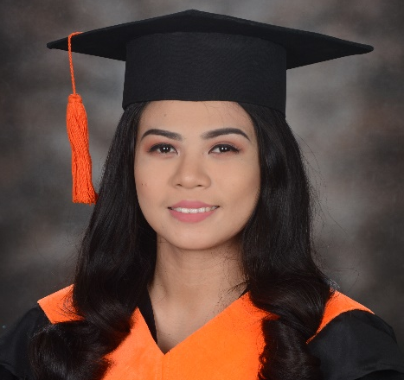
JOVEJOY MARASIGAN CO

Sitio Pulo Brgy. Maduya, Carmona, Cavite
Email: jovejoy.m.co@gmail.com
Contact No.: 09481764553

CAREER OBJECTIVES

To utilize my high degree of skill, work efficiency and organizational skills to contribute for the overall success of the organization.

SKILLS

- Proficient in Microsoft Office word and excel.
- Editing skills using Adobe Photoshop.
- Familiar with basic knowledge of computer skills.
- Knowledge of database Queries using MySQL.
- Knowledge in Oracle database Queries.
- Communication skills.

WORK EXPERIENCE

Jollibee (Service Crew) April 2012 – June 2018
YCPC and PARTS (On-The-Job Training) June – July 2017

EDUCATIONAL ATTAINMENT

- Cavite State University – Carmona Campus 2010 - 2012
Bachelor of Science in Information Technology 2016 – 2018
Graduate
- Binan Secondary School of Applied Academics 2005 – 2009

SEMINARS

- MaxIT 2017: Coding the Future Right November 11, 2017
- Seize the Future: The Ultimate Guide of What I.T. can Offer November 23, 2017
- Technopreneurship: Empowering Business Through Technology November 25, 2017
- DEVolution 2017: Revolving Android Development in Today’s Generation November 25, 2017
- Pre-Employment Seminar April 24, 2018
- Total Quality Management Seminar April 25, 2018

PERSONAL INFORMATION

Age: 25
Birthday: August 23, 1993
Gendert: Female
Civil Status: Single
Religion: Iglesia Ni Cristo

REFERENCES

- Mr. Marvin Miranda ARMM3 Manager (Jollibee, Pacita Complex)
- Mr. Kevin D. Celadina Analyst Software Engineer (09777303009)
- Ms. Regene G. Hernandez IT Department Head (Cavite State Universtiy)

I hereby certify that the above information is true and correct to the best of my knowledge and beliefs.

___________________
JOVEJOY M. CO
Applicant

