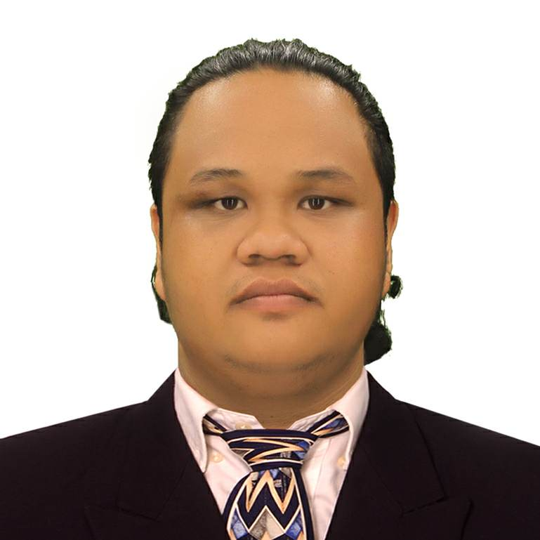
Tristian B. Barja
tristian_barja@yahoo.com
09167911021 / 09122197997
#115, Sitio Rizal, CENA, Alabang, Muntinlupa City
Career Objective
Secure a position in a creative and dynamic work environment where I can apply my skills in Information Technology.
TECHNICAL SKILLS
- Webpage Designing (HTML5, CSS3, JavaScript, Bootstrap)
- Programming (Visual Basic.net, C#.net, Arduino programming)
- Database Administration (MySql, MS Access)
- PC Troubleshooting and Repair
- Others:
    - Adobe Photoshop
    - Adobe Dreamweaver
    - Adobe InDesign
    - Microsoft Office
PERSONAL SKILLS
- English Literate
- Team Player
- Highly Resourceful
- High level of maturity and sense of responsibility
WORK EXPERIENCE
- IT Lecturer (Webpage Design, Visual Studio, Adobe Photoshop)
Informatics Computer Institute
Tabaco City
June 2014-December 2016
- Graphics Artist
Bacacay Tourism Office
Bacacay, Albay
May 2014
PRE-PROFESSIONAL EXPERIENCE
- IT Intern (VMS, Content Creator, Graphics Designer)
TopJuan Consulting Inc.
Northgate CyberZone, Alabang, Muntinlupa City
February 2018 – April 2018
EDUCATIONAL ATTAINMENT
- Bachelor of Science in Information Technology
Informatics International College
Northgate CyberZone, Alabang, Muntinlupa City
2016-2018
- Advance Diploma in Information Technology
Informatics Computer Institute
Tabaco City
2010-2013
AWARDS AND AFFILIATIONS
- President – Student Council, Informatics International College, 2017-2018
- President – Student Council, Informatics Computer Institute, 2012-2013
- Red Cross Youth – Rizal Chapter, 2017
- Bicol-IT Organization – Member, 2015- Present
- Credit Honors (2nd Honors) – Informatics Computer Institute, 2013
REFERENCES
- Mary Ann C. Dizon
Marketing Head, Informatics International College
772-2476
- Dunn Christopher Noble
Lecturer/OSA Coordinator, Informatics International College
09064459609
- Maribel Guese
Course Consultant, Informatics International College
772-2474
_______________________
TRISTIAN B. BARJA

