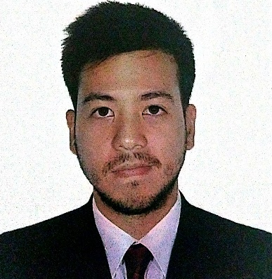
MIGUEL PAOLO D. DELA CRUZ

23 Avocado Street, Phase 2
Pacita Complex 2, San Pedro city
Laguna, Philippines 4023
(+639) 278530369
miguelpaolodelacruz@yahoo.com

Experienced service advisor in an automotive dealership with both customer service and technical background striving to leverage automotive experience and education acquired from international studies

EDUCATION

2011 – 2015 bishop state community college – mobile, AL (USA)
Associates Degree in Automotive Technology minor in Diesel Mechanics
351 N Broad Street, Mobile, Alabama 36603 USA
2016 – 2017 bishop state community college – mobile, AL (USA)
Studying AAS in Computer Information Systems (sophomore)
351 N Broad Street, Mobile, Alabama 36603 USA

WORK HISTORY

02.2018 – PRESENT SERVICE ADVISOR – TOYOTA ALABANG SERVICE CENTER
Preventive Maintenance and General Service
- Frontliner of the service reception
- Recieves and recommends maintenance or repair requests to customers.
- Answers customer‘s technical inquiries regarding their vehicle while providing quality customer service
- Upsells ancillary products, parts and accessories to customers for better vehicle experience and peace of mind

08.2017 – 12.2017 Capital one Philippines support services corp. – alabang, muntinlupa (philippines)
Sr. operations representative – BPO
- Branded book servicing department – Handled general credit card account information and promoting digital solutions to credit card holders.

02.2015 – 05. 2017 BIG CHARLIE’S PRODUCE – MOBILE, AL (USA)
Processing – Food service
- Prepared, processed, arranged and delivered large scale produce orders for several schools, restaurants and grocery stores.

Qualifications

Computer skills : Typing 60 wpm, proficient in scan/copy/fax/e-mail

Computer programs : SAP ERP, ERA, AllData, Microsoft Office applications

Languages spoken : Filipino (Tagalog) and English

Qualities : Customer service, multi-tasking, automotive diagnosing, being attentive and strong listening skills, excellent communication skills, can work independently or collaboratively, able to deal with all types of customers and work under pressure, being proactive, motivated and committed in getting the job done right

PERSONAL INFORMATION

Date of Birth : August 14, 1990
Age : 29
Height : 5’3”
Sex : Male
Civil Status : Single
Nationality : Filipino

