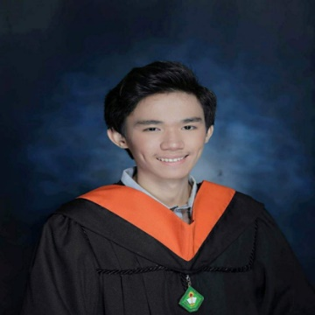
MICHAEL ANGELO TOLENTINO TAMAYO
Blk. 46 Lot. 30 Gentree Villas, Pasong Kawayan 1, General Trias, Cavite
09967634345
michaeltamayo10@yahoo.com

Objective:
Seeking a position in life to utilize my skills and abilities and achieve professional growth while being resourceful, innovative and flexible. To add valuable assets to your esteemed organization as an active member.

Work Experience:
Encoder
J&T Vetement Inc.
September 2019 – January 2020
184-185 Mindanao Avenue, G. Maderan, GMA Cavite

Production Encoder
Visionex Garments Subcon Services
January 2019 – September 2019
184-185 Mindanao Avenue, G. Maderan, GMA Cavite

CCTV Installer/Computer Technician
Fixurcomp Enterprises
December 2018 – January 2019
Service Lane 15, SM City Molino, Bacoor Cavite

MDI Contractor/Field Engineer (Philippine National Bank Project)
Infinite Power System Inc. (On – the – Job Training)
Santolan, Quezon City

Skills:
- Microsoft Visual Studio (Management Information System)
- PC/Laptop System Restore, Assembly and Troubleshooting
- Basic Networking
- CCTV (IP CAM, ANALOG CAM) Installing & Troubleshooting
- Improvised DATABASE
- Website Developing
- Microsoft Office Applications

Seminars Attended:
“Decision Support System”, “Mobile Development”, “Careers @ the Largest Search Engine”, “Multimedia Business”, “System Security Intermediate Level”, and “Cyber Security Awareness & Fundamentals and Ethical Hacking Workshop” at Cavite State University – Bacoor City Campus

“Introduction to Fusion 360”, and “Part Modeling Assembly in Fusion 360” at De La Salle Santiago Zobel School Ayala Alabang

Educational Attainment:
Tertiary : Bachelor of Science in Information Technology 2014 – 2018
Cavite State University - Bacoor City Campus
Soldiers Hills Phase 4, Molino VI, Bacoor City, Cavite

Secondary : Secondary Education 2010 – 2014
St. Michael’s Institute
Poblacion Bacoor City, Cavite

Primary : Elementary Education 2004 – 2010
Talaba Elementary School
Talaba Bacoor City, Cavite

Personal Background:
Age : 21 years old
Date of Birth : September 10, 1998
Place of Birth : Bacoor City, Cavite
Height : 5’6”
Weight : 58 kg
Civil Status : Single
Citizenship : Filipino
Languages : English and Tagalog
Father’s Name : Rodolfo P. Tamayo JR.
Mother’s Name : Hernaly T. Tamayo

Character Reference:
Roneson Angelo Abug
Professor at Cavite State University – Bacoor City Campus
Jesibel R. Rosales
Dep Ed Teacher at Bacoor National High School

I hereby certify that the above-mentioned information is true and correct to the best of my knowledge.

TAMAYO, MICHAEL ANGELO TOLENTINO

